University of Canberra

Faculty of Science and Technology

**Programming for Data Science G (11521)**

**Week 10 Tutorial**

**Python packages: NumPy, Matplotlib and Scikit-learn**

**Question 1**:

* Add the following lists to your program

#Question 1

list1 = [1, 2, 3, 4]

list2 = [3, 4, 5, 6]

list3 = [5, 6, 7, 8]

* Then write your code to convert them to array and have the following output

**Answer 1**:

mylist = [list1, list2, list3]

myarray = np.array(mylist)

print(myarray)

**Answer 2**:

a1 = np.array(list1)

a2 = np.array(list2)

a3 = np.array(list3)

myarray = np.stack((a1, a2, a3))

print(myarray)

**Answer 3**:

mylist = []

mylist.append(list1)

mylist.append(list2)

mylist.append(list3)

myarray = np.array([list1, list2, list3])

print(myarray)

**Question 2:**

* Write your code to print the last 2 columns of the array in Example 2

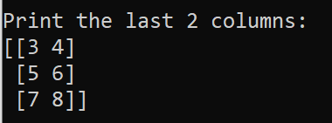

**Answer**:

print('Print the last 2 columns: ')

print(myarray[:, -2:])

**Question 3:**

* Write your code to print elements in the last 2 rows and first 2 columns of the array in Example 2

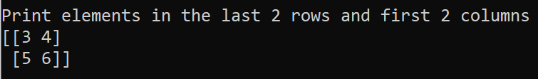

**Answer**:

print('Print elements in the last 2 rows and first 2 columns : ')

print(myarray[-2:, :2])

**Question 4:**

* Write your code using **reshape**, **transpose**, and **flatten** functions (in Week 9 lecture) on the array in Example 2 to produce the following outputs

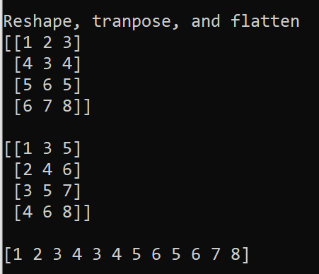

**Answer**:

print('Reshape, tranpose, and flatten')

print(myarray.reshape(4, 3))

print()

print(myarray.T)

print()

print(myarray.flatten())

print()

**Question 5**: Iris dataset. Modify the program in **Example 14** to load data samples in different colours (**red**, **green**, and **blue**) and different markers (**circle**, **square**, and **triangle**) for 3 data classes (**setosa**, **versicolour**, and **virginica**). The first 50 samples are setosa, the next 50 samples are versicolour, and the last 50 samples are virginica.

**Answer**:

import matplotlib.pyplot as plt

from sklearn import datasets

iris = datasets.load_iris()

X = iris.data[:, :2] # we only take the first two features.

y = iris.target

labels = iris.target_names

print(labels)

c = ['r', 'g', 'b'] #3 colours for 3 classes

m = ['o', 's', '^'] #3 markers for 3 classes

XX = [(X[:50,0], X[:50,1]), (X[50:100,0], X[50:100,1]), (X[100:150,0], X[100:150,1])]

# Plot the training points

for i in range(3):

plt.scatter(XX[i][0], XX[i][1], label=labels[i], c=c[i], marker=m[i], s=30)

plt.xlabel('Sepal length')

plt.ylabel('Sepal width')

plt.title('Iris dataset')

plt.legend()

plt.show()